

# 

### Semester One Examination, 2018

### Question/Answer booklet

# MATHEMATICS

If required by your examination administrator, please place your student identification label in this box

**METHODS**

**UNIT 3**

## Section Two:

## Calculator-assumed

|  |  |  |  |  |  |  |  |  |  |  |
| --- | --- | --- | --- | --- | --- | --- | --- | --- | --- | --- |
| Student number: In figures |  |  |  |  |  |  |  |  |  |  |

In words

Your name

## Time allowed for this section

Reading time before commencing work: ten minutes

Working time: one hundred minutes

## Materials required/recommended for this section

***To be provided by the supervisor***

This Question/Answer booklet

Formula sheet (retained from Section One)

***To be provided by the candidate***

Standard items: pens (blue/black preferred), pencils (including coloured), sharpener,  
correction fluid/tape, eraser, ruler, highlighters

Special items: drawing instruments, templates, notes on two unfolded sheets of A4 paper, and up to three calculators approved for use in this examination

## Important note to candidates

No other items may be taken into the examination room. It is **your** responsibility to ensure that you do not have any unauthorised material. If you have any unauthorised material with you, hand it to the supervisor **before** reading any further.

## Structure of this paper

|  |  |  |  |  |  |
| --- | --- | --- | --- | --- | --- |
| Section | Number of questions available | Number of questions to be answered | Working  time (minutes) | Marks available | Percentage of examination |
| Section One:  Calculator-free | 8 | 8 | 50 | 52 | 35 |
| Section Two:  Calculator-assumed | 13 | 13 | 100 | 98 | 65 |
|  | | |  | **Total** | 100 |

## Instructions to candidates

1. The rules for the conduct of examinations are detailed in the school handbook. Sitting this examination implies that you agree to abide by these rules.

2. Write your answers in this Question/Answer booklet.

3. You must be careful to confine your response to the specific question asked and to follow any instructions that are specified to a particular question.

4. Supplementary pages for the use of planning/continuing your answer to a question  
have been provided at the end of this Question/Answer booklet. If you use these pages to continue an answer, indicate at the original answer where the answer is continued, i.e. give the page number.

5. Show all your working clearly. Your working should be in sufficient detail to allow your answers to be checked readily and for marks to be awarded for reasoning. Incorrect answers given without supporting reasoning cannot be allocated any marks. For any question or part question worth more than two marks, valid working or justification is required to receive full marks. If you repeat any question, ensure that you cancel the answer you do not wish to have marked.

6. It is recommended that you do not use pencil, except in diagrams.

7. The Formula sheet is not to be handed in with your Question/Answer booklet.

Section Two: Calculator-assumed 65% (98 Marks)

This section has**thirteen (****13)** questions. Answer **all** questions. Write your answers in the spaces provided.

Working time: 100 minutes.

Question 9 (6 marks)

$78\%$ of the fish in a large inland lake are known to be trout. Ten fish are caught at random from the lake every day.

(a) Describe, with parameters, a suitable probability distribution to model the number of trout in a day's catch. (2 marks)

(b) Determine the probability that there are fewer trout than fish of other species in a day's catch. (2 marks)

(c) Calculate the probability that over two consecutive days, a total of exactly $19$ trout are caught. (2 marks)

Question 10 (8 marks)

The population of a city can be modelled by $P=P_{0}e^{kt}$, where $P$ is the number of people living in the city, in millions, $t$ years after the start of the year $2000$.

At the start of years $2009$ and $2013$ there were $1 945 000$ and $2 061 000$ people respectively living in the city.

(a) Determine the value of the constant $k$. (2 marks)

(b) Determine the value of the constant $P_{0}$. (2 marks)

(c) Use the model to determine during which year the population of the city will first exceed $2 500 000$. (2 marks)

(d) Determine the rate of change of the city's population at the start of $2013$. (2 marks)

Question 11 (6 marks)

The graph of $f(x)=\begin{matrix}6x+1 \\ \overline{ x+1 }\end{matrix}$ is shown below.

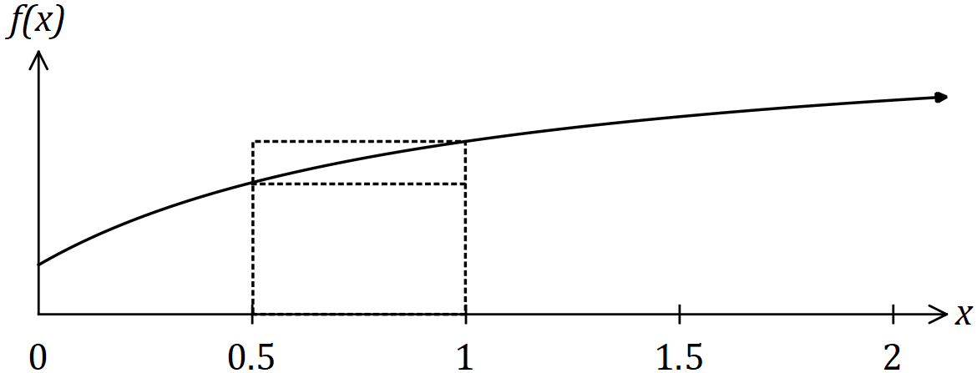

Two rectangles are also shown on the graph, with dotted lines, and they both have corners just touching the curve. The smaller is called the inscribed rectangle and the larger is called the circumscribed rectangle.

(a) Complete the missing values in the table below. (1 mark)

|  |  |  |  |  |  |
| --- | --- | --- | --- | --- | --- |
| $$x$$ | $$0$$ | $$0.5$$ | $$1$$ | $$1.5$$ | $$2$$ |
| $$f(x)$$ |  | $$\frac{8}{3}$$ | $$\frac{7}{2}$$ |  | $$\frac{13}{3}$$ |

(b) Complete the table of areas below and use the values to determine a lower and upper bound for $\int_{0}^{2}{\underset{ }{\overset{ }{f(x)}}}dx$. (4 marks)

|  |  |  |  |  |
| --- | --- | --- | --- | --- |
| $x$ interval | $0$ to $0.5$ | $0.5$ to $1$ | $1$ to $1.5$ | $1.5$ to $2$ |
| Area of inscribed rectangle |  |  |  |  |
| Area of circumscribed rectangle | $$\frac{4}{3}$$ |  |  |  |

(c) Explain how the bounds you found in (b) would change if a larger number of smaller intervals were used. (1 mark)

Question 12 (8 marks)

A fairground shooting range charges customers $\$6$ to take $9$ shots at a target. A prize of $\$20$ is awarded if a customer hits the target three times and a prize of $\$40$ is awarded if a customer hits the target more than three times. Otherwise no prize money is paid.

Assume that successive shots made by a customer are independent and hit the target with the probability $0.15$.

(a) Calculate the probability that the next customer to buy $9$ shots wins

(i) a prize of $\$20$. (2 marks)

(ii) a prize of $\$40$. (1 mark)

(b) Calculate the expected profit made by the shooting range from the next $30$ customers who pay for $9$ shots at the target. (3 marks)

(c) Determine the probability that more than $6$ out of the next $8$ customers will not win a prize. (2 marks)

Question 13 (8 marks)

Three functions are defined by $f\left(x\right)=9e^{-0.07x}, g\left(x\right)=3e^{0.09x}$ and $h\left(x\right)=3$.

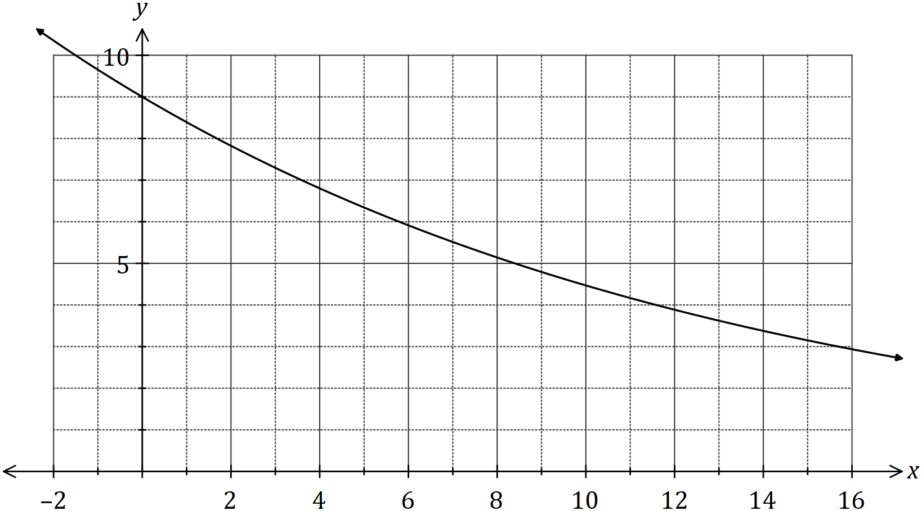

(a) One of the functions is shown on the graph above. Add the graphs of the other two functions. (3 marks)

(b) Working to three decimal places throughout, determine the area of the region enclosed by all three functions. (5 marks)

Question 14 (7 marks)

A fuel storage tank, initially containing $3 750$ L, is being filled at a rate given by

$$\begin{matrix}dV \\ \overline{dt}\end{matrix}=\frac{t^{2}(240-3t)}{500}, 0≤t≤80$$

where $V$ is the volume of fuel in the tank in litres and $t$ is the time in minutes since filling began. The tank will be completely full after $80$ minutes.

(a) Calculate the volume of fuel in the tank after half-an-hour. (3 marks)

(b) Determine the time taken for the tank to fill to three-quarters of its maximum capacity.

(4 marks)

Question 15 (8 marks)

The discrete random variable $X$ has a mean of $5.28$ and the following probability distribution.

|  |  |  |  |  |  |
| --- | --- | --- | --- | --- | --- |
| $$x$$ | $$3$$ | $$4$$ | $$5$$ | $$6$$ | $$7$$ |
| $$P(X=x)$$ | $$0.15$$ | $$a$$ | $$b$$ | $$0.2$$ | $$0.2$$ |

(a) Determine the values of the constants $a$ and $b$. (3 marks)

(b) Determine $P\left(X<4 | X<7\right)$. (2 marks)

(c) Determine

(i) $\operatorname{Var}{(X)}$. (1 mark)

(ii) $E⁡(100-15X)$. (1 mark)

(iii) $\operatorname{Var}{(12-5X)}$. (1 mark)

Question 16 (9 marks)

A particle starts from rest at $O$ and travels in a straight line.

Its velocity ms-1, at time $t$ s, is given by $v=8t-t^{2}$ for $0≤t≤3$ and $v=135t^{-2}$ for $t>3$.

(a) Determine the initial acceleration of the particle. (2 marks)

(b) Calculate the change in displacement of the particle during the first three seconds.

(2 marks)

(c) Determine, in terms of $t$, an expression for the displacement, $x$ m, of the particle from $O$ for $t>3$. (2 marks)

(d) Determine the distance of the particle from $O$ when its acceleration is ms-2.

(3 marks)

Question 17 (7 marks)

A random sample of $n$ components are selected at random from a factory production line. The proportion of components that are defective is $p$ and the probability that a component is defective is independent of the condition of any other component.

The random variable $X$ is the number of faulty components in the sample. The mean and standard deviation of $X$ are $30.6$ and $5.1$ respectively.

(a) Determine the values of $n$ and $p$. (4 marks)

(b) After changes are made to the manufacturing process, the proportion of defective components is now $3\%$. Determine the smallest sample size required to ensure that the probability that the sample contains at least one defective component is at least $0.95$.

(3 marks)

Question 18 (11 marks)

The air pressure, $P(h)$ in kPa, experienced by a weather balloon varies with its height above sea level $h$ km and is given by

$$P\left(h\right)={101.5e}^{-0.135h}, 0≤h≤20 .$$

(a) Determine $\begin{matrix}dP \\ \overline{dh}\end{matrix}$ when the height of the balloon is $5.5$ km. (2 marks)

(b) What is the meaning of your answer to (a). (1 mark)

The height of the balloon above sea level varies with time $t$ minutes and is given by

$$h\left(t\right)=\frac{t^{2}(120-t)}{12800}, 0≤t≤80 .$$

(c) Determine the air pressure experienced by the balloon when $t=48$. (2 marks)

(d) Determine $\begin{matrix}dh \\ \overline{dt}\end{matrix}$ when the height of the balloon is $7.04$ km. (3 marks)

(e) Determine $\begin{matrix}dP \\ \overline{dt}\end{matrix}$ when the height of the balloon is $7.04$ km. (3 marks)

Question 19 (7 marks)

The hourly cost of fuel to run a train is proportional to the square of its speed and is $\$36$ per hour when the train moves at a speed of kmh-1. Other costs amount to $\$144$ per hour, regardless of speed.

(a) Show that when the train moves at a steady speed of kmh-1, where , the total cost per kilometre, $C$, is given by (3 marks)

$$C=\frac{9x}{64}+\frac{144}{x}.$$

(b) Use calculus to determine the minimum cost for the train to travel $240$ km, assuming that the train travels at a constant speed for the entire journey. (4 marks)

Question 20 (6 marks)

The discrete random variable $X$ is defined by

$$P\left(X=x\right)=\left\{\begin{matrix}\frac{2k}{e^{1-x}} & x=0, 1 \\ & \\ 0 & \text{elsewhere.}\end{matrix}\right.$$

(a) Show that $k=\begin{matrix}e \\ \overline{2+2e}\end{matrix}$. (3 marks)

(b) Determine, in simplest form, the exact mean and standard deviation of $X$. (3 marks)

Question 21 (7 marks)

The graph of $y=f(t)$ is shown below, where $f(t)=5\sin\left(\begin{matrix}πt \\ \overline{ 4 }\end{matrix}\right)$.

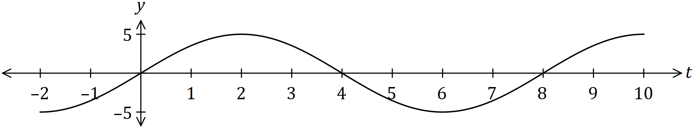

(a) Determine the exact area between the horizontal axis and the curve for $0≤t≤4$.

(2 marks)

Another function, $F$, is defined as $F(x)=\int_{0}^{x}{\underset{ }{\overset{ }{f(t)}}}dt$ over the domain $0≤x≤16$.

(b) Determine the value(s) of $x$ for which $F(x)$ has a maximum and state the value of $F(x)$ at this location. (2 marks)

(c) Sketch the graph of $y=F(x)$ on the axes below. (3 marks)

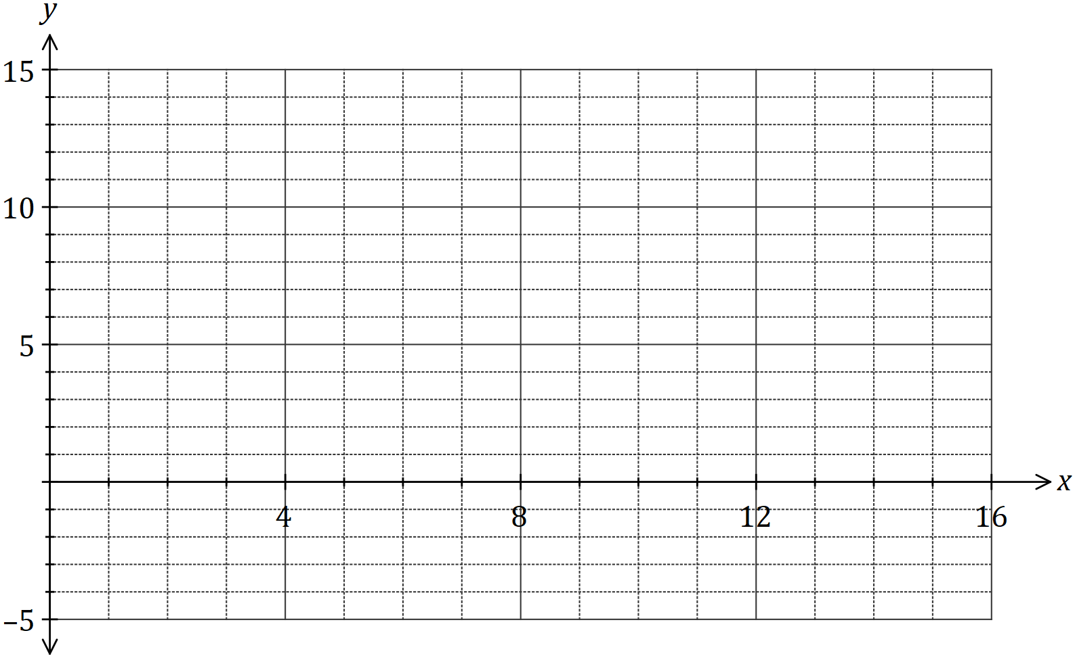

Supplementary page

Question number: _________

Supplementary page

Question number: _________

Supplementary page

Question number: _________

|  |  |  |
| --- | --- | --- |
| Markers use only | | |
| Question | Maximum | Mark |
| 9 | 6 |  |
| 10 | 8 |  |
| 11 | 6 |  |
| 12 | 8 |  |
| 13 | 8 |  |
| 14 | 7 |  |
| 15 | 8 |  |
| 16 | 9 |  |
| 17 | 7 |  |
| 18 | 11 |  |
| 19 | 7 |  |
| 20 | 6 |  |
| 21 | 7 |  |
| S2 Total | 98 |  |
| S2 Wt (×0.6633) | 65% |  |